  80th ANNIVERSARY   

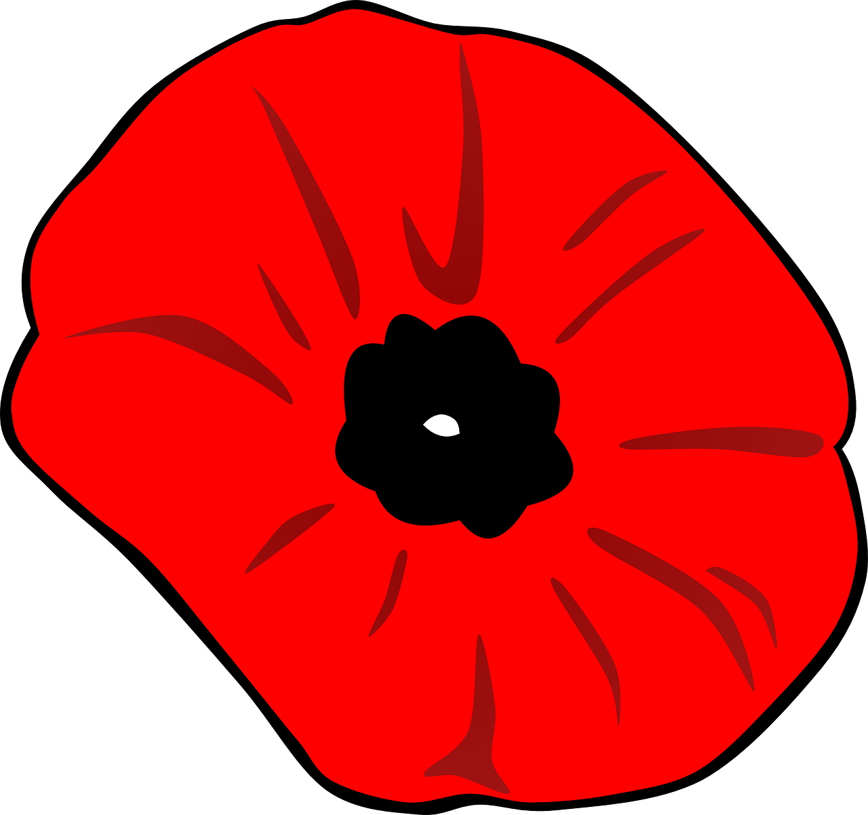

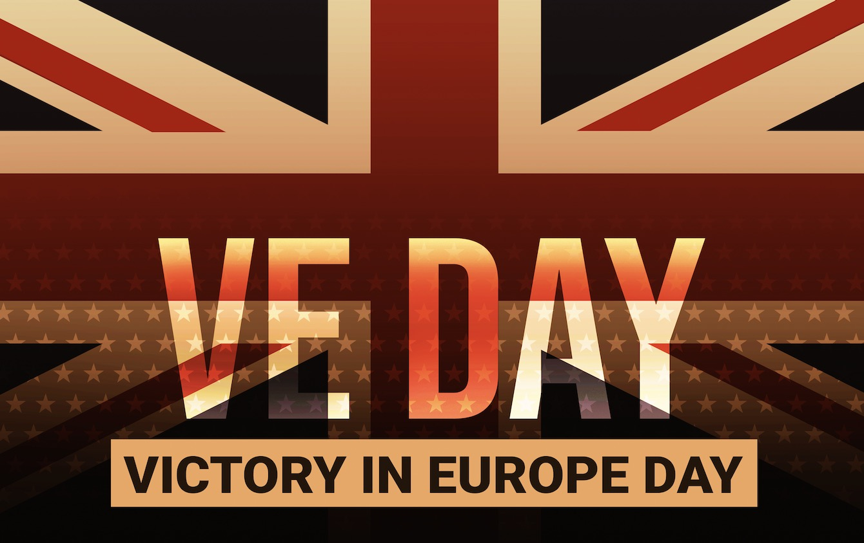

MONDAY 5th MAY, 2.00-5.00pm

UPTON VILLAGE HALL.

**Free** Village Hall event supported by Upton History Group & Parish Council.

Displays & memorabilia, music & light refreshments

If you have any photo’s or memories to share we’d love to see & hear them. Please bring them along or contact Ginny on 01493 750932

        